# ABSTRACT:

Customer can make reservation for stay in hotel. The reservation data is managed by Employee of the hotel. Reservation generates invoice which is to be paid by customer. Reservation contains room details.

Room details can also be accessed by the customer, if any, room details also contains room damage details.

# PROJECT DESCRIPTION:

We have created a database schema according to following requirements:

1. Hotel stores employee data as their unique emp-id, Name (First, Middle, Last), Phone no. and Job-type.
2. Employee manages the reservation made by the customer, they also serve to various customer requirements.
3. Customer data is also store by the hotel as their unique Customer Id, Complete Name, E-mail, DOB and country.
4. Invoice contains bill amount, invoice status and Invoice id which is generated by the reservation which contains data as Reservation no., chk in date, chk out date and stay duration.
5. Reservation contains Room details as Room no., Room Price and Room type, and further, if any, contains Room Damage Details.
6. Not all employees manage reservations.
7. All reservations are made by customer.
8. A customer may have several room details.
9. Invoice is only generated if customer makes a reservation.
10. If any, Room damage details have data like Room damage id, Repair status and damage amount.

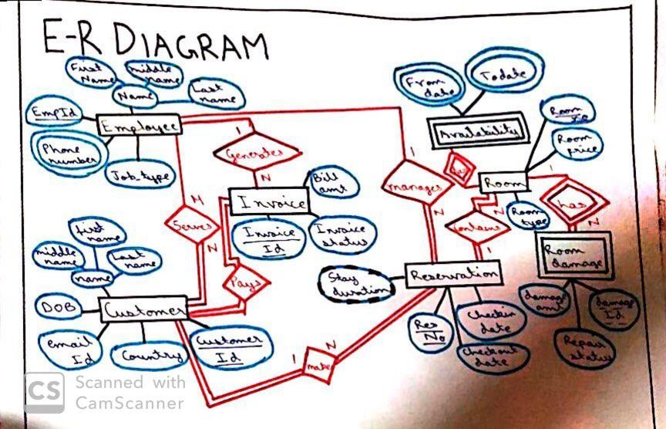

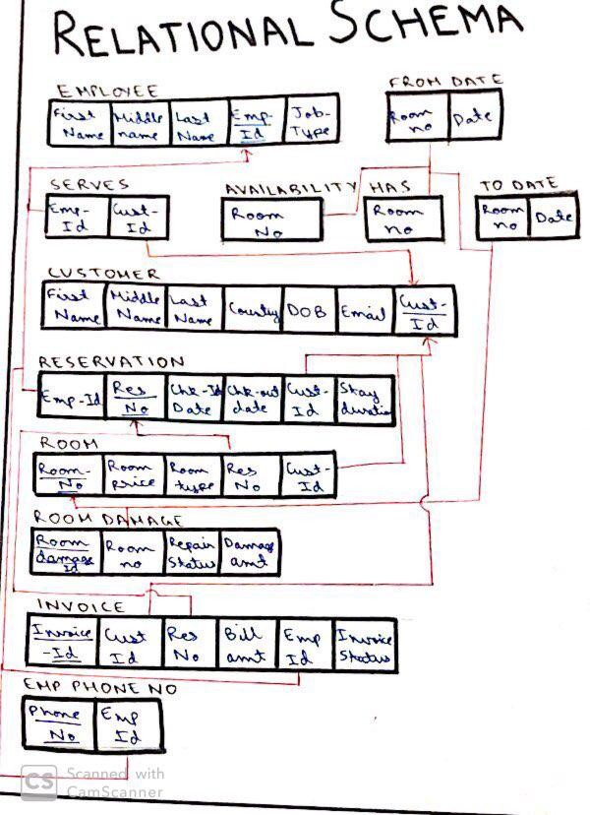

### SQL QUERIES:

**Created employee table**

create table Employee ( First_N varchar2(10), Middle_N varchar2(10),

Last_N varchar2(10), Job_type varchar2(5), Emp_id number(5)

);

### Inserted values in to employee table

insert into Employee values ( 'Akshat','','Gupta','OFF',1111);

insert into Employee values

( 'Ishaan','','Jain','CLS',1112);

insert into Employee values

( 'Tim','John','Snik','RECP',1113);

insert into Employee values

( 'Sahil','Sunil','Jain','OFF',1114);

insert into Employee values

( 'Muskan','','Tewari','CLS',1115);

Select * from Employee;

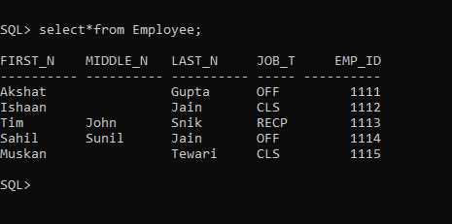

### Room Table

create table Room ( Room_No number(3),

Room_Price number(5), Room_type varchar2(4), Res_No number(5), Cust_id number(5)

);

### Inserted values in to room table

insert into Room values

( 101,2500,'STD',1234,8922);

insert into Room values

( 102,3500,'PREM',2345,8925);

insert into Room values

( 103,3000,'DEL',7822,8933);

insert into Room values

( 104,2550,'STD',5627,6743);

insert into Room values ( 105, 7500, 'PLUS',6574,7843);

select * from Room;

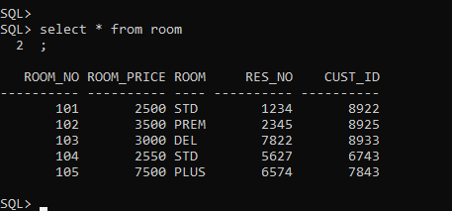

### Creating customer table

create table Customer ( First_N varchar2(10), Middle_N varchar2(10),

Last_N varchar2(10), Email varchar2(20),

Country varchar2(10), DOB date,

Cust_id number(5)

);

### Inserting data into customer table

insert into Customer values (

'Muskan','','Tewari','muskantewari1@gmail.com','India',date '1996-08-02',8922);

insert into Customer values (

'Piyush','Sunil','Thakur','piyush98@gmail.com','China',date '1992-06-22',8925);

insert into Customer values ( 'Suresh','','Shukla','suresh66@gmail.com','India',date '1989-02-11',

8933);

insert into Customer values (

'Akshat','','Gupta','akshatgupta@gmail.com','Canada',date '1997-11-10',6743);

insert into Customer values ( 'Neha','','Parihar','neha91@gmail.com','Canada',date '1991-10-30',

7843);

select * from Customer;

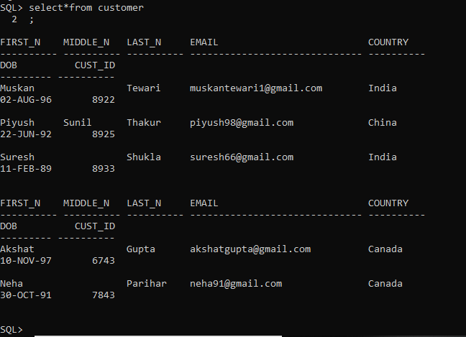

### Created Room_damage table

create table Room_damage

( Room_damage_id number(5),

Room_no number(3),

Repair_status varchar2(10), Damage_amt number(5),

constraint room_dam_pk primary key (Room_damage_id,Room_no)

);

### Inserting values into room_damage table :

insert into Room_damage values ( 6734,102,'PENDING',550);

insert into Room_damage values ( 7923,103,'DONE',400);

insert into Room_damage values (

2343,102,'DONE',2000);

insert into Room_damage values ( 7802,101,'PENDING',700);

insert into Room_damage values ( 8923,101,'DONE',780);

Select * from Room_damage

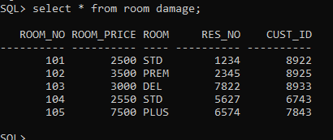

### Created Serves table

create table Serves ( Emp_id number(5), Cust_id number(5), constraint serves_pk primary key (Emp_id,Cust_id)

);

### Insert into Serves table

insert into Serves values ( 1113,8922);

insert into Serves values ( 1111,8925);

insert into Serves values ( 1114,8933);

insert into Serves values ( 1113,6743);

insert into Serves values ( 1111,7843);

select * from Serves;

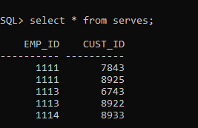

### Created invoice table

create table Invoice (

Emp_id number(5), Inv_id number(5),

Cust_id number(5), Res_No number(5),

Bill_amt number(5), Inv_status varchar2(10), constraint invoice_four_pk primary key (Emp_id, Inv_id, Cust_id,Res_no)

);

### Inserted values in invoice table

insert into Invoice values ( 1111,10223,7843,6574,12550,'PENDING');

insert into Invoice values

( 1111,10312,8925,2345,5600,'PAID');

insert into Invoice values

( 1113,10232,6743,5627,7800,'PAID');

insert into Invoice values ( 1113,10126,8922,1234,2550,'PENDING');

insert into Invoice values

( 1114,10187,8933,7822,9800,'PAID');

select * from Invoice;

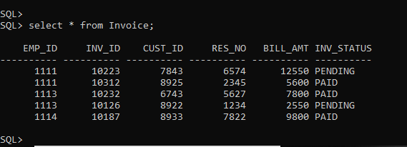

### Reservation table created

create table reservation ( Emp_id number(5), Cust_id number(5), Res_no number(5), Chk_in date,

Chk_out date,

Stay_dur number(3) as (Chk_out - Chk_in)

);

### Inserting into reservation table

insert into reservation (emp_id, cust_id, res_no, chk_in, chk_out) values (1111,7843,6574,date '2018-06-18',date '2018-06-22');

insert into reservation (emp_id, cust_id, res_no, chk_in, chk_out) values (1111,8925,2345,date '2018-07-09',date '2018-07-11');

insert into reservation (emp_id, cust_id, res_no, chk_in, chk_out) values (1113,6743,5627,date '2018-07-06',date '2018-07-15');

insert into reservation (emp_id, cust_id, res_no, chk_in, chk_out) values (1113,8922,1234,date '2018-08-04',date '2018-08-07');

insert into reservation (emp_id, cust_id, res_no, chk_in, chk_out) values (1114,8933,7822,date '2018-09-22',date '2018-09-28');

select * from reservation;

### Reservation table

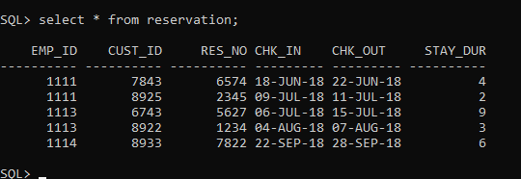

**All table primary key**

alter table Employee

add constraint Emp_id_pk primary key (Emp_id);

alter table serves

add constraint serves_pk primary key (Cust_id, Emp_id);

alter table customer

add constraint customer_pk primary key (Cust_id);

alter table reservation

add constraint reservation_pk primary key (Res_no);

alter table room

add constraint room_pk primary key (Room_no); alter table room_damage

add constraint room_damage_pk primary key (Room_damage_id, Room_no);

alter table invoice

add constraint invoice_pk primary key (Cust_id, Emp_id, Inv_id, Res_no);

alter table emp_phone_no

add constraint emp_phone_no_pk primary key (Phone_no, Emp_id);

### All foreign key linking

alter table Serves add constraint serves_fk foreign key (Emp_id) references Employee(Emp_id);

alter table Serves

add constraint serves_fk2 foreign key (Cust_id) references Customer(Cust_id);

alter table Reservation

add constraint serves_fk3 foreign key (Emp_id) references Employee(Emp_id);

alter table Reservation

add constraint serves_fk4 foreign key (Cust_id) references Customer(Cust_id);

alter table Room

add constraint serves_fk5 foreign key (Res_no) references Reservation(Res_no);

alter table Room add constraint serves_fk6 foreign key (Cust_id) references Customer(Cust_id);

alter table Room_damage

add constraint serves_fk7 foreign key (Room_no) references Room(Room_no);

alter table Invoice add constraint serves_fk8 foreign key (Emp_id) references Employee(Emp_id);

### Dealing with multi-valued attributes

create table Emp_phone_no

( Emp_id number(5), Phone_no number(10),

constraint Emp_phone_fk foreign key (Emp_id) references Employee (Emp_id)

);

create type phone_no as varray(5) of number(38); alter table Employee

add emp_phone Phone_no;

update Employee set Emp_phone =

Phone_no(9415118032,9616103567)

where Emp_id=1111;

update Employee set Emp_phone = Phone_no(9792977807) where Emp_id=1112;

update Employee set Emp_phone = Phone_no(6758334567,8977878234)

where Emp_id=1113;

update Employee set Emp_phone = Phone_no(88929392934) where Emp_id=1114;

update Employee set Emp_phone = Phone_no(6672738672) where Emp_id=1115;

### select * from employee;

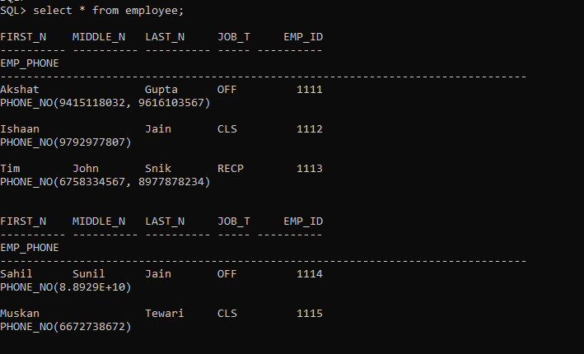

**QUERIES**

**Alter**

alter table Employee modify job_type varchar2(5)

constraint emp_nn not null;

### Delete

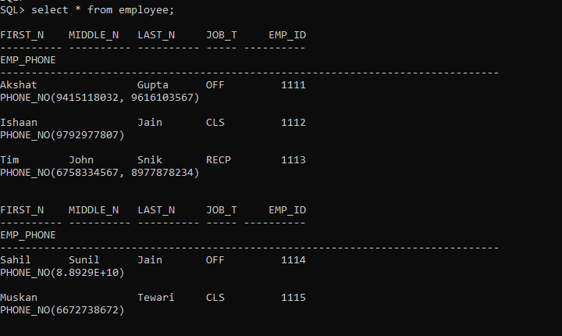

Delete from Employee where emp_id=1117;

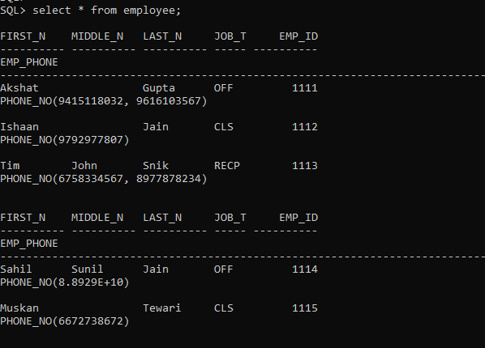

No record found.

### Select with where clause

select * from Employee where Emp_id=1111;

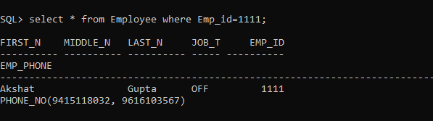

### Comparison Operator

select * from Reservation where stay_dur > 2;

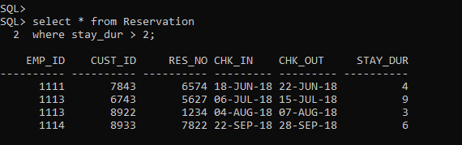

select * from Reservation where emp_id = 1113;

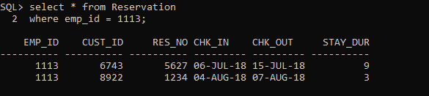

select * from Reservation where stay_dur <= 6;

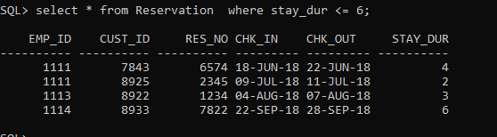

select * from Room where room_price < 3000;

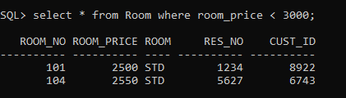

select * from Room_damage where damage_amt > 600;

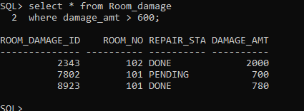

### Aggregate functions

select count(*) from Customer;

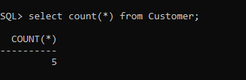

select max(inv_id) from Invoice;

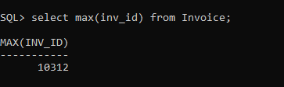

select min(room_no) from Room;

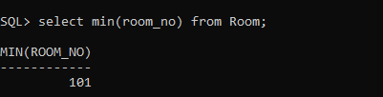

select avg(room_price) from Room;

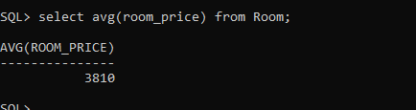

select sum(dama ge_amt) from room_damage;

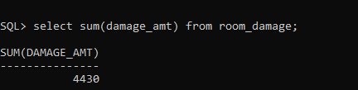

### Numeric functions

select sqrt(cust_id) from Customer; select abs(inv_id) from Invoice; select sign(room_no) from Room; select round(room_price) from Room;

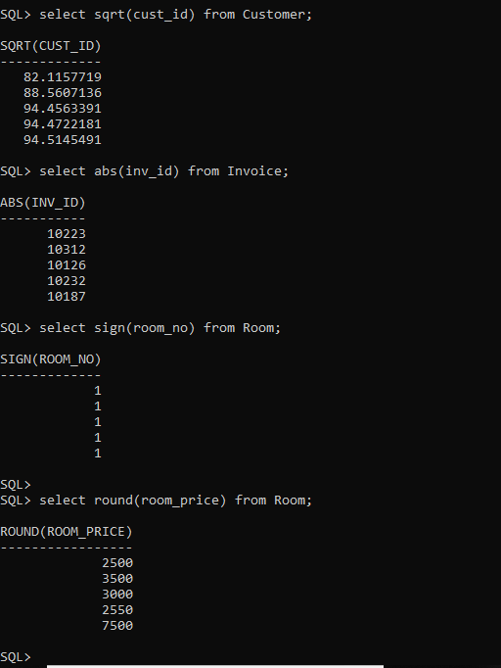

select sin(damage_amt) from room_damage;

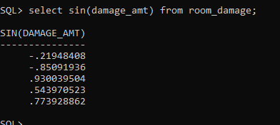

### String function

select lower(inv_status) from Invoice; select upper(First_n) from Employee; select reverse(Middle_n) from Customer;

select lpad(First_N, 10, '@') from Customer;

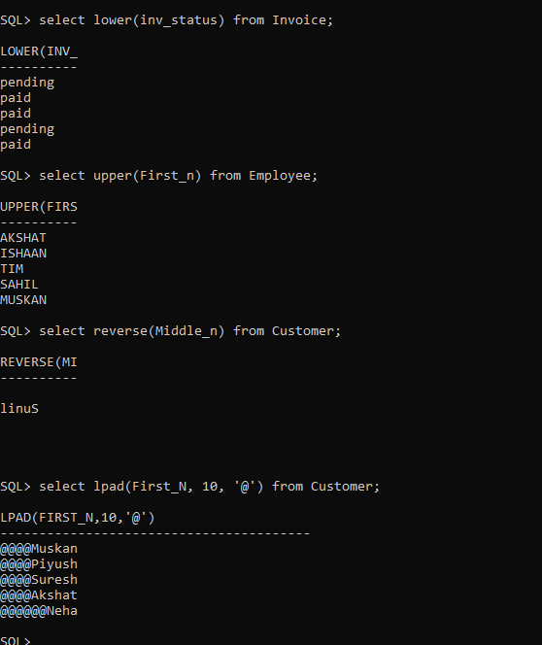

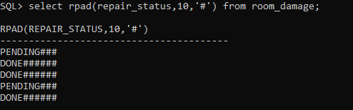select rpad(repair_status,10,'#') from room_damage;

### Date functions

select last_day(chk_in) from reservation;

select add_months(chk_out,2) from reservation; select round(chk_in, 'year') from reservation; select trunc(chk_out,'day') from reservation;

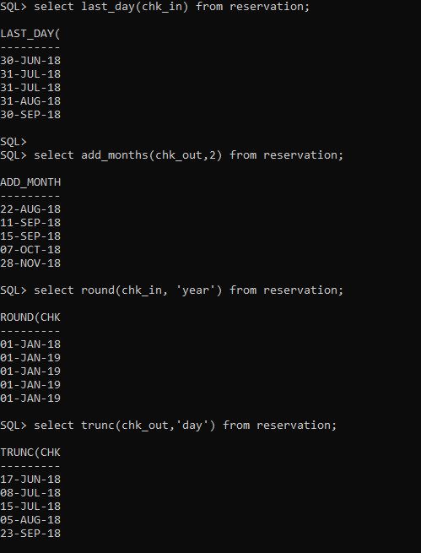

select next_day(chk_in,'Wednesday') from reservation;

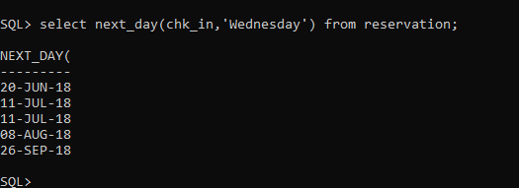

### Conversion functions

select to_char(room_price) from room;

select to_char(chk_in) from reservation; select to_date(chk_out) from reservation;

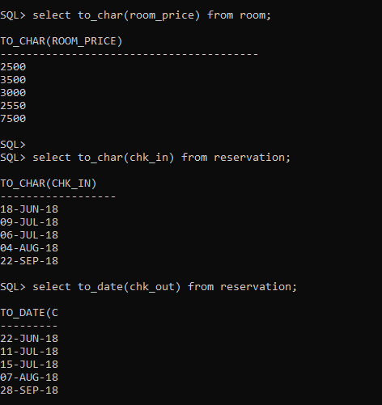

### Set operator

select emp_id, cust_id from Invoice union all

select emp_id, cust_id from Reservation;

select emp_id, cust_id from Invoice intersect

select emp_id, cust_id from Reservation;

select emp_id from Employee minus

select emp_id from Reservation;

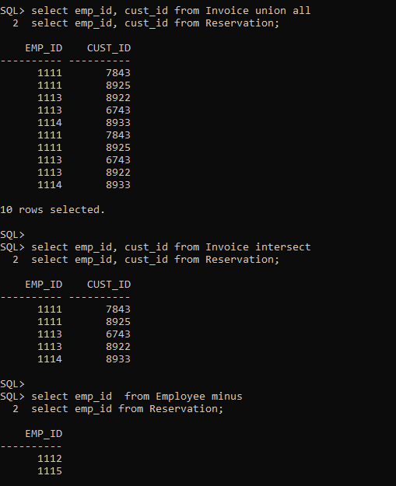

### Group by and having

select count(cust_id), country from Customer group by country;

select count(cust_id), country from Customer group by country

having count(cust_id) >= 2;

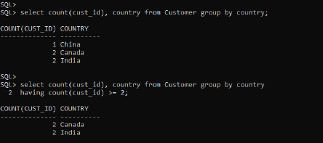

### Order by clause

select * from Customer order by First_n;

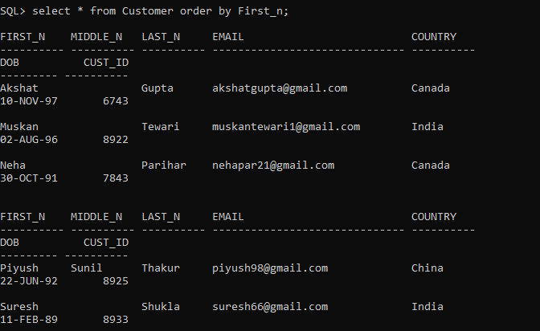

### Join queries - more than two tables (three)

**Join**

select first_n, room_damage.room_no, room_price from customer, room, room_damage where room.cust_id = customer.cust_id and room.room_no = room_damage.room_no ;

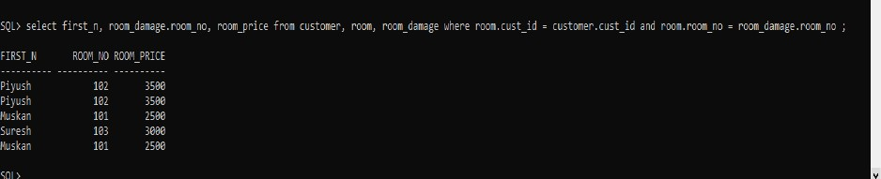

Select reservation.cust_id, invoice.res_no, bill_amt from reservation, invoice, room where room.res_no = invoice.res_no and room.cust_id = invoice.cust_id;

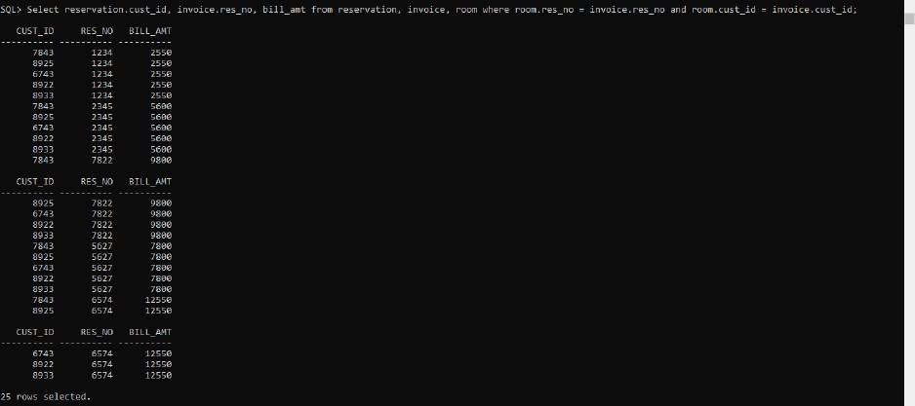

select employee.first_n, customer.first_n, serves.emp_id from employee, serves, customer where employee.emp_id = serves.emp_id and customer.cust_id = serves.cust_id;

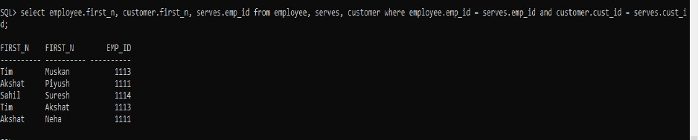

### Subquery

select first_n from customer where cust_id in (select cust_id from reservation where stay_dur = 2);

select room_no, cust_id from room where room_no in (select room_no from room_damage where damage_amt > 500);

select first_n, middle_n, last_n from customer where cust_id in (select cust_id from invoice where inv_status = 'PAID');

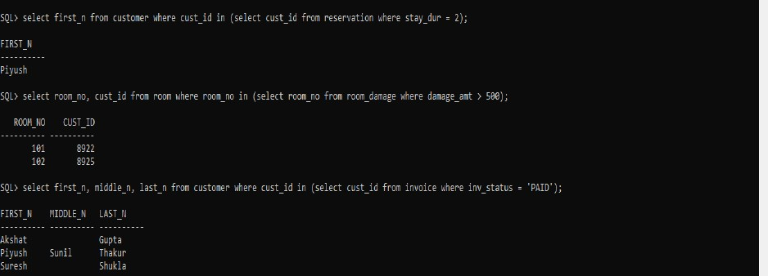

### Views

create view v1 as select * from customer;

select * from v1;

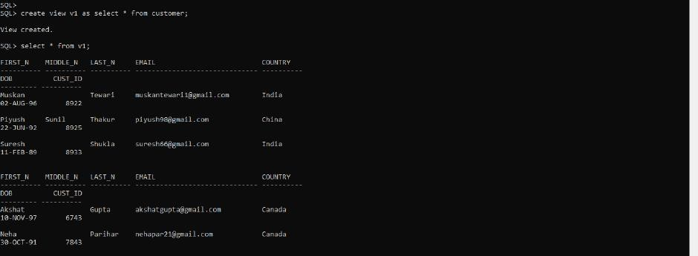

create view name as select first_n, middle_n, last_n from customer; select * from name;

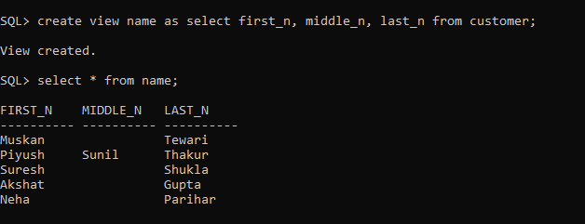

# PROCEDURAL QUERIES

### Cursor

Set serveroutput on; declare country varchar2(5); cursor c2 is select * from customer where country='India';

rows c2%rowtype;

begin open c2; loop fetch c2 into rows; exit

when c2%notfound; dbms_output.put_line(ro ws.first_n); end loop; close c2;

end;

/

Statement processed.

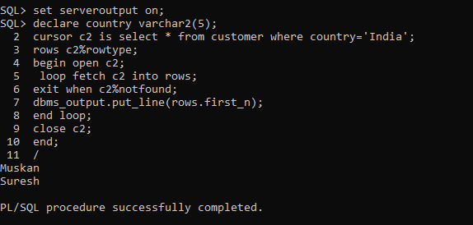

### Procedure

create or replace procedure isPrem(price in room.room_no%type, guess out varchar) is cost number; begin select room_price into cost from room where room_price=price; if cost >= 2900 then

guess := 'This room is the Premium Room.'; else

guess :='This room is not the Premium Room.'; end if;

end;

/

Procedure created.

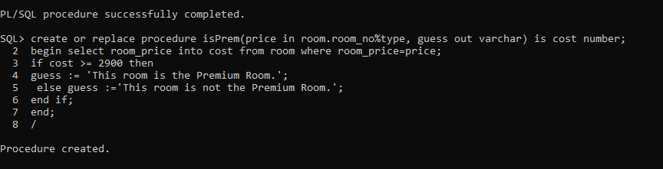

variable v varchar2(10); exec isPrem(101,:v); print v;

Statement processed.

This room is not the Premium Room.

### Function

create or replace function concession(no number) return number is

cost number; begin select room_price into cost from room where room_no=no;

cost:= cost/15; return cost; end

concessio n;

/

Function created.

declare no number; begin no:=102;

dbms_output.put_line(conc ession(no));

end;

/

Statement processed. 233.333333333333333333333333333333333333

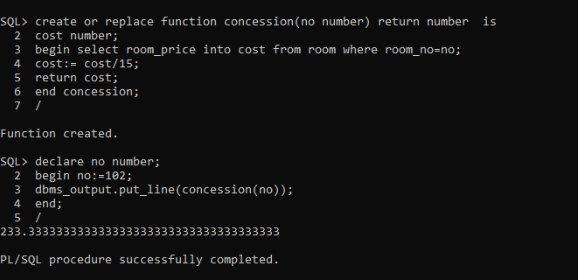

### Trigger

create or replace trigger t2 before update on room

for each row declare diﬀ number; begin

diﬀ := :NEW.room_price - :OLD.room_price;

dbms_output.put_line('Price before updation: '||:OLD.room_price); dbms_output.put_line('Price after updation: '||: NEW.room_price); dbms_output.put_line('Diﬀerence between the prices: '|| diﬀ); end;

/

Trigger created.

update room set room_price = 2800 where room_no = 104; 1 row(s) updated.

Price before updation: 2550 Price after updation: 2800

Diﬀerence between the prices: 250